Biostatistics practicum

Assignment 1

3rd June 2026

Due date: 24th June 2025

Total marks: 100 (code: 35, results: 45, report format: 20)

For this assignment you will need to prepare a short report in word, and submit the report along with your do file (including comments) by the beginning of the lecture on 24th June.

You will be marked for both your do file and your report. Make sure your do file is commented so your responses to each question are clearly visible. Do NOT include results in the do file – put them in your word document. Also, do NOT simply copy paste results from your results window into word. Make nice tables that are legible and clear.

When you prepare your report, be sure to use headings and page breaks to separate the questions, make a table of contents, use figure captions, make a table of figures and a table of tables, and lay everything out nicely.

For this assignment you will receive 20 marks for the formatting of the report. If you do not follow the MS Word strategies you learnt in lecture 4, you will lose marks. The distribution of the remaining marks is given in the questions themselves.

The assignment questions also give you some information about the number of lines of code you should need to answer the question. This is a guide, not a requirement!

Question 1: Setup [10 points: code 5 points, results 5 points]

Download the LVMI file and place it in your working directory. Then, open a Stata do file, save it in the working directory with the name “Stata code assignment 1 [Student ID]”. In the do file, set your working directory and use the LVMI file.

- Take a screenshot of this working directory, and insert the screenshot into your report. [5]

Question 2: Descriptive statistics [25 points: code 10 points, results 15 points]

The data set LVMI.dta contains measurements of Left Ventricular Mass Index (LVMI), a measure of the enlargement of the left side of the heart with height corrected in units g/m^{2.7}, for 224 children and adolescents aged 10-18. High LVMI may predict cardiovascular disease in children when they get older. The data contains information on the children’s age, gender, blood pressure category (bpcat) and body mass index (BMI). The data dictionary is provided as below.

No | Variable names | Unit | Code
1 | ID
2 | LVMI | g/m^{2.7}
3 | gender |  | 1 = boy, 2 = girl
4 | bpcat |  | 1 = normal, 2 = pre-hypertensive, 3 = hypertensive
5 | age | Years
6 | BMI | kg/m²

Open this data in Stata. Show the following (marks for results are shown in brackets):

- The mean LVMI and its variance and standard deviation for the whole sample [4]
- The mean BMI and its variance and standard deviation for the whole sample [4]
- Generate a new variable which indicates whether or not each subject is overweight, defining overweight as a BMI greater than or equal to 25. Use the tabulate command to show the number and proportion of people who are overweight. [2]
- Using the tabstat command, calculate the mean LVMI and standard error separately for people who are overweight and not overweight. Do you think that there is a difference in LVMI by weight? [5]

Expected code: 6 lines including the use command

Question 3: Graphical methods [20 points: code 10 points, results 10 points]

Again using the LVMI data, answer the following (marks for results in brackets):

- Using the twoway command generate a scatter plot of LVMI against BMI (LVMI on the y-axis, BMI on the x-axis), with axis labels. Once you produce it you can use graph save to save it, and graph export to export to an image file [5]
- Based on your figure, and your answers to question 2, do you think that there is a relationship between LVMI and BMI? Describe it [5]

Expected code: 3 lines, 6 if you save your graphs as well as export them, and maybe a few extra lines to make nice labels if you want.

Question 4: Rates and line plots [25 points: code 10 points, results 15 points]

The file suicideData202606.dta contains data on the total number of suicide deaths, the total number of deaths due to hanging (a form of suicide) and the population of Japan, by sex and year, from 1980 to 2015. Variables in the data are:
- Sex, 1=male, 2=female
- Year, from 1980 to 2015
- hangingDeaths, the number of suicide deaths due to hanging for that sex in the given year
- totalSuicideDeaths, the total number of suicide deaths for that sex in the given year
- pop, the population of that sex in that year

Please conduct the following analyses (marks for the results shown in brackets):
- using the generate command, make a variable showing the rate of total suicide deaths per 100,000 population Using the twoway command, plot the rate for men and women in the same figure, so that it looks like figure 1 below. Make sure to include a legend. Note that the y axis may not start at 0 in your default plot, and you may need to fiddle with the yscale(), yticks() and ylabels() options. [5]
- Using the generate command, make a variable showing the proportion of suicide deaths in each year that were due to hanging. Plot this using the twoway command, with the proportion for men and women in the same figure. Add a vertical grey line at the year 1998, when the suicide rate suddenly increases. It should look like figure 2 below. You will need to do some internet searching to figure out how to put a vertical line. Try it! Note in this case you don’t need to start the y axis at 0 – if you do, you will see that the details of the trend are hard to see because it is compressed into a small area [5]
- Write a brief description of the main trends and properties in this data [5]

When you insert the figures in your report, be sure to give them captions!

Expected code: 9 lines (less if you don’t separate your graphing code to look neat over multiple lines)
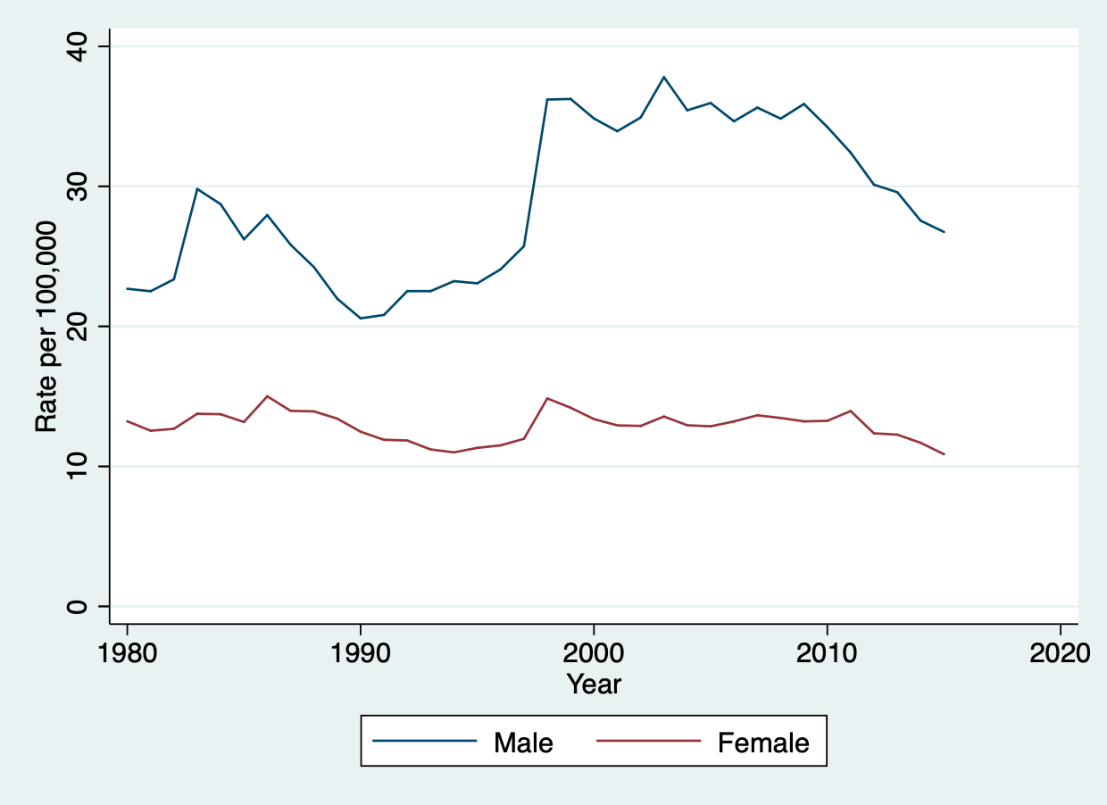
Figure 1: The first figure for your report

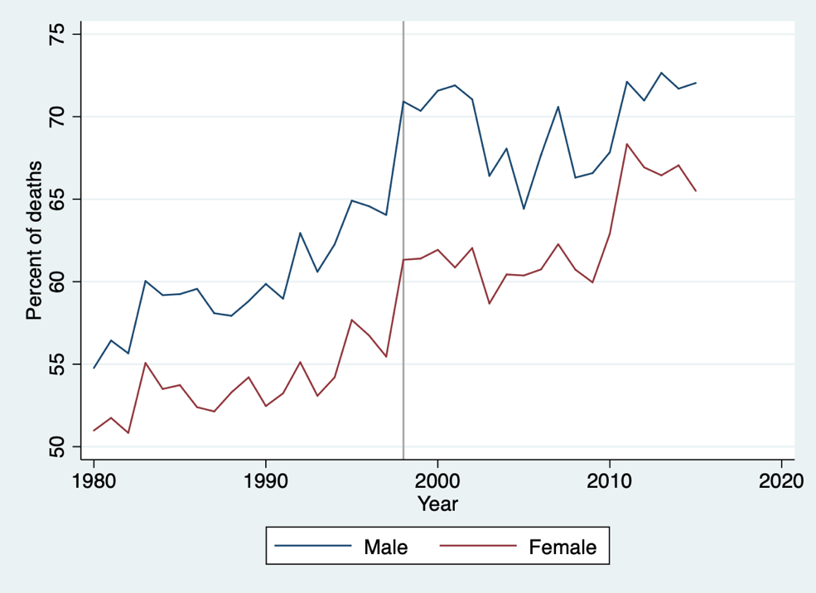
Figure 2: The second figure

